CURRICULUM VITAE

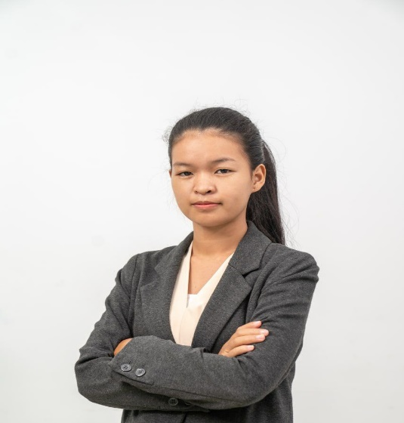

**Date** **:** Feb / 21 / 2023

**Name : HORN SAORY**

Address : Phum Mouy, Sangkat Tumnob Tuek, Khan Chamkar Mon

, Kampong Speu Province, Cambodia.

Tel : 017 420 268

G-mail : [hornsaory17@gmail.com](mailto:hornsaory17@gmail.com)

Apply for: Import Assistant

**PERSONAL DATA:**

Name : HORN SAORY

Sex : Female

Nationality : Cambodian

Date of Birth : 04-Mar-2002

Place of Birth : Chek Village, Cheung Roas Commune, Odongk District, Kampong Speu Province

Marital Status : Single

Height : 1.56m

Health : Very good

EDUCATIONAL BACKGROUND:

2018-2022 : Gradated Bachelor Degree of Business Management at Human Resource University (HRU)

2015-2018 : Finished grade 12(BccII) at Bunrany Hunsan Chanthnal high school

2012-2015 : Finished at Banteay Khmer secondary school

2006-2012 : Finished at Banteay Khmer primary school

TRAINING COURSES:

|  |  |  |
| --- | --- | --- |
|  |  |  |
| 2018-2021 | : Intermediate program Level 1-4 program, HRU of English File Book |
| 2017-2018: | : Successfully completed the computer typing, (Microsoft Word, Excel, and Power Point. |  |

**WORK EXPERIENCES:**

**2022-Present : Work as Recruitment Consultant at Asean Works Recruitment**

* Negotiating Contracts
* Headhunting
* Interviewing and Assessing prospective applicant and matching them with vacancies at client companies
* Screening candidates and drawing up shortlists of candidate for client to interview
* Organizing interview and selection events
* Make arrangement for the advertisement of vacancies
* Helping applicants to prepare for interviews
* Building relationship with Candidates and clients.

**2021-Oct 2022 : Work as Cashier at DFI Lucky Private Limited**

* Welcome to our customer
* Manage transaction with customers using cash registers
* Scan goods and ensure pricing is accurate
* Collect payment whether in cash or credit
* Cross-Sell products and introduce new ones
* Resolve customer complaints, guide them and provide relevant information
* Greet customers when entering or leaving the store
* Closing and report cash to Supervisor
* And other tasks assign by Supervisor.

**2020-Mar2021 : Work as Operations Support Apprentice at Wing (Cambodia) Bank**

* Data Entry all information customer’s include ID Card, Diver’s License and passport
* Entering customer and account data from source documents within time limited
* Compiling, Verifying accuracy and sorting information to prepare source data for computer entry
* Review data for deficiencies or errors, correcting any incompatibilities and checking output
* And other tasks assign by Supervisor.

**2020-Mar2020 : Work as Administration Volunteer at HRU**

LANGUAGES IN USE:

Khmer : Mother tongue

English : Speaking, Wring, Listening and Reading (Medium)

HOBBIES AND INTERESTS:

⮚ Read book, do research, Playing E-mail, Playing G-mail, watch news and up to date

Technology.

Strengths

Good heath, creative, self-confident, good communication, is able to work under pressure, flexibility and responsibility over circumstances.

REFFERENCES:

|  |  |  |
| --- | --- | --- |
| * **Name** | **: Mr. CHHENG RAVUTH** | |
| -Organization | **:**  Teacher English at Home International School. | |
| -H/P | **: 011 917 787** | |
|  |  | |
|  |  | |
|  |  | |
|  |  | |
|  | |
|  |  | |
|  |  | |